**PANOSETI Quabo Firmware Release #8.2**

RR December 2, 2019

This corrects a logical problem in the resetting of the four-phase elapsed time counters in 8.1 which caused 1 of every four elapsed-time codes to be missing. Here’s the timing output from this test in which a variable-delay pulse is slaved to the 1PPS from the WR master and stepped through 100ps steps, recording the elapsed-time value from quabo at each step:

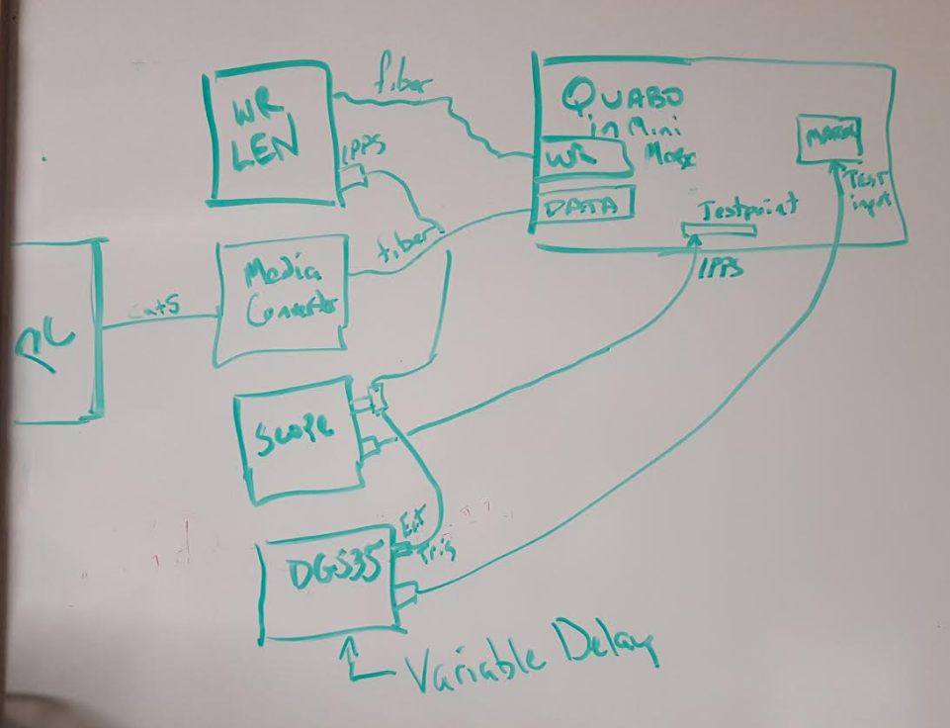

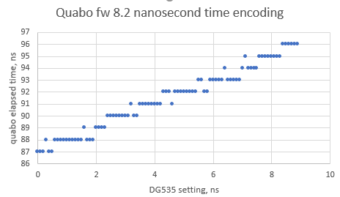

The DG535 isn’t really capable of measuring the performance; the delay setting has about +-200ps of jitter, and there are step-size variations, too. But we can see that all the codes are present.